**Experiment no. 2**

**Name: Sonali Dattatray Kaingade**

**PRN: 21620002**

**Title:** To perform normalization of data (Min-max and z-score).

**1. Min max normalization**

**Code:**

#include <iostream>

#include <fstream>

#include <vector>

#include <algorithm>

using namespace std;

double min_max_scaling(double x, double x_min, double x_max, double x_newmin, double x_newmax) {

    return ((x - x_min) / (x_max - x_min)) * (x_newmax - x_newmin) + x_newmin;

}

int main() {

    ifstream input_file("input.txt");

    ofstream output_file("output_minmax.txt");

    vector<double> data;

    double value;

    while (input_file >> value) {

        data.push_back(value);

    }

    double x_min = *min_element(data.begin(), data.end());

    double x_max = *max_element(data.begin(), data.end());

    double x_newmin = 1.0; // New minimum value for scaled data

    double x_newmax = 10.0; // New maximum value for scaled data

    for (const double &x : data) {

        double normalized_value = min_max_scaling(x, x_min, x_max, x_newmin, x_newmax);

        output_file << normalized_value << endl;

    }

    input_file.close();

    output_file.close();

    cout << "output is generated in output_minmax file" << endl;

    return 0;

}

**Output:**

**input.txt**

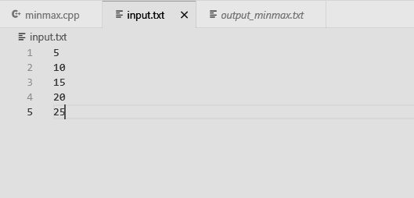

**Output_minmax.txt**

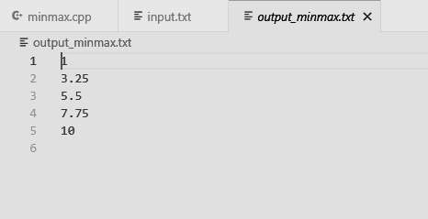

**2. Z-score normalization**

**Code:**

#include <iostream>

#include <fstream>

#include <vector>

#include <algorithm>

#include <cmath>

using namespace std;

double z_score(double x, double mean, double std_dev) {

    return (x - mean) / std_dev;

}

int main() {

    ifstream input_file("input.txt");

    ofstream output_file("output_zscore.txt");

    vector<double> data;

    double value;

    while (input_file >> value) {

        data.push_back(value);

    }

    double sum = 0.0;

    for (const double &x : data) {

        sum += x;

    }

    double mean = sum / data.size();

    double squared_diff_sum = 0.0;

    for (const double &x : data) {

        squared_diff_sum += pow(x - mean, 2);

    }

    double std_dev = sqrt(squared_diff_sum / data.size());

    for (const double &x : data) {

        double normalized_value = z_score(x, mean, std_dev);

        output_file << normalized_value << endl;

    }

    input_file.close();

    output_file.close();

    cout << "output is generated in output_zscore file" << endl;

    return 0;

}

**Output:**

**input.txt:**



**Output_zscore.txt:**

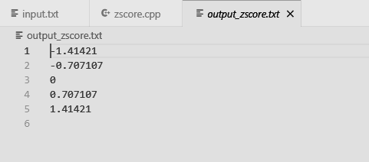

**Knime:**

**Min-Max Normalization:**

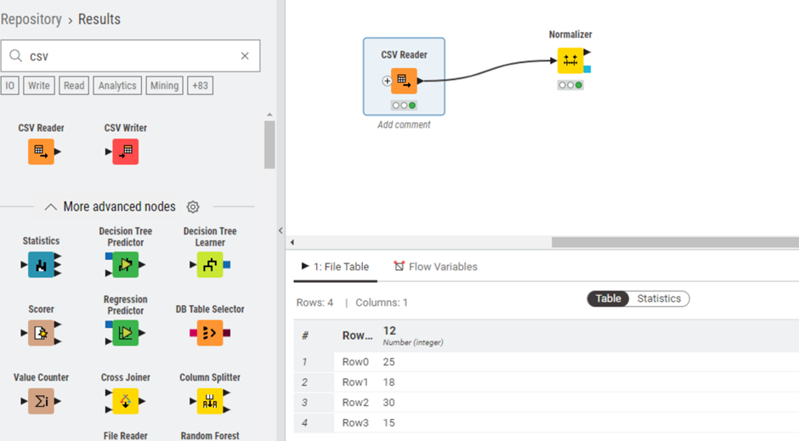

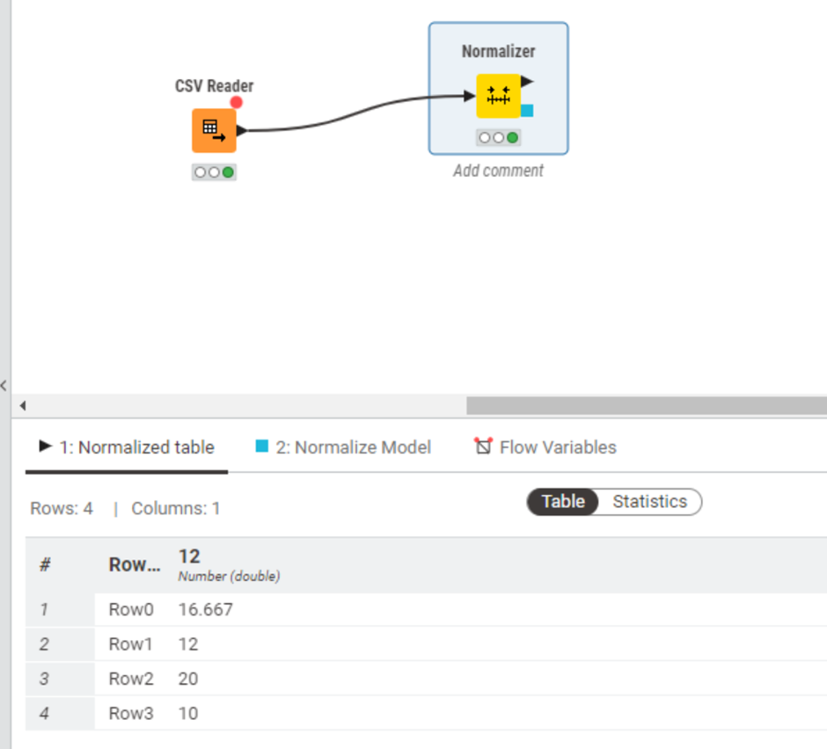

**Z - Score Normalization:**

